Harsh Vardhan Kushwaha

17BCN7017

PL SQL Lab Exercise 4

Cursors

1. Retrieve the employee details using cursors.

Code –

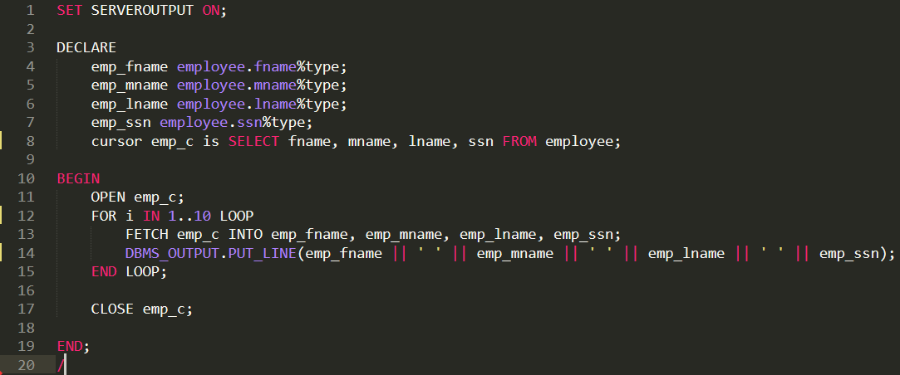

Output –

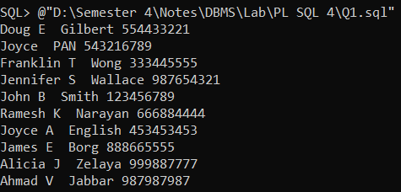

1. Write a cursor program to display all the employee and department details.

Code –

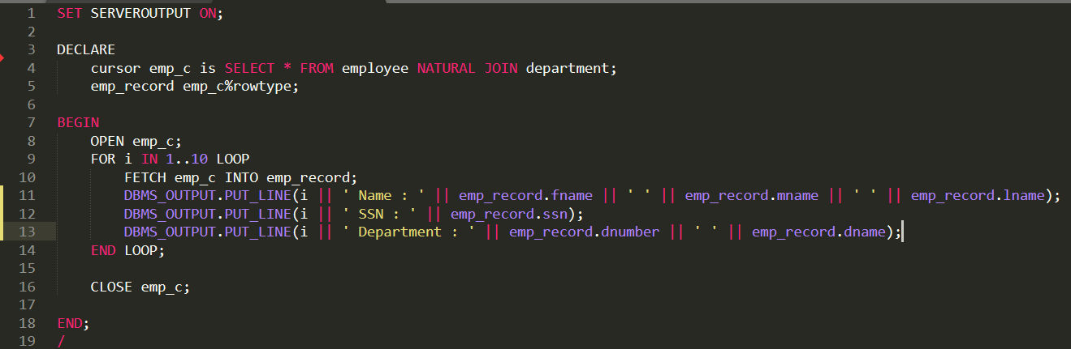

Output –

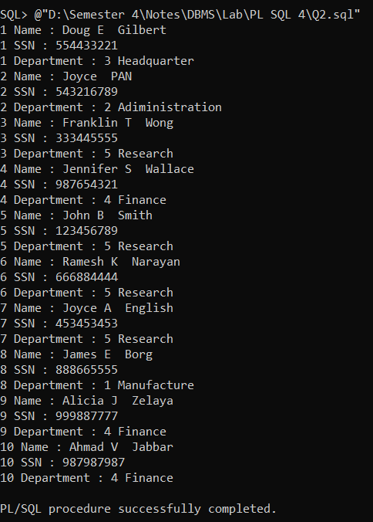

FUNCTION

1. Write a function to give the number of employees for a given Department name.

Code –

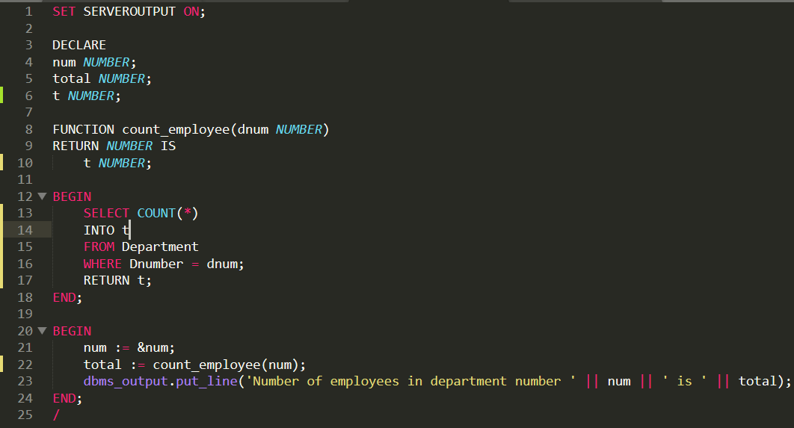

Output –

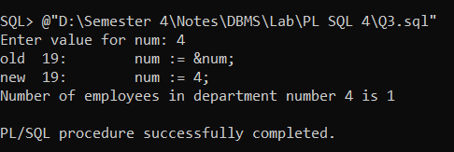

1. Write a PL/SQL to find the factorial of the given number using function.

Code –

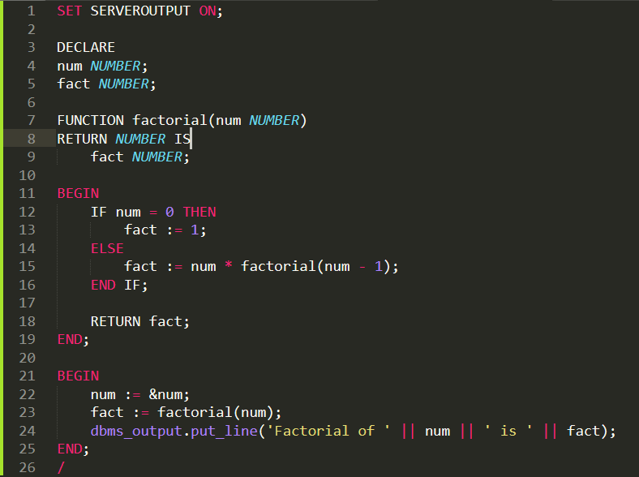

Output –

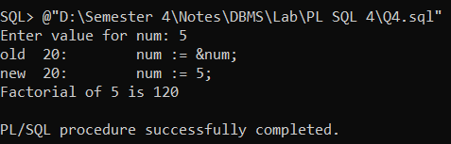

Procedure

1. Write a procedure to accept an employee name and display his Department names.

Code –

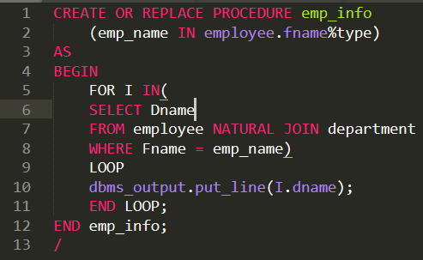

Output –

